- Website specification
Objective:
The ACEGEAR TENNIS RACKET WEBSITE is a modern tennis racket website designed to help players find the perfect racket based on their skill level, playing style, and budget. The website aims to provide useful information, product comparisons, and an engaging user experience.
Goals:
- Provide high-quality information about tennis rackets.
- Help users compare different rackets.
- Create an interactive and user-friendly platform.
- Promote tennis equipment to a wider audience.
Target Audience:
- Age group: 15–35 years.
- Beginner to intermediate tennis players.
- Tech-savvy users who browse on mobile and desktop.
- Interested in sports and online shopping.
Type of Website:
E-commerce and informational website focused on tennis rackets, including product listings, comparisons, and educational guides.
- Information Design & Taxonomy
- HOME
- Introduction to the brand
- Featured rackets
- Promotions and highlights

- Rackets (Product Category)
Subcategories:
- Beginner Rackets
- Intermediate Rackets
- Professional Rackets

Each product includes:
- Image
- Name
- Price
- Specifications (weight, grip, balance)

- Compare
- Side-by-side comparison of rackets
- Features such as:
  - Weight
  - Power
  - Control
  - Material

- Guide
Content includes:
- How to choose a racket
- Grip size explanation
- Weight and balance guide
- Tips for beginners

- Contact
- Contact form
- Email input
- Message section

A storyboard flowchart for the ace gear tennis racket

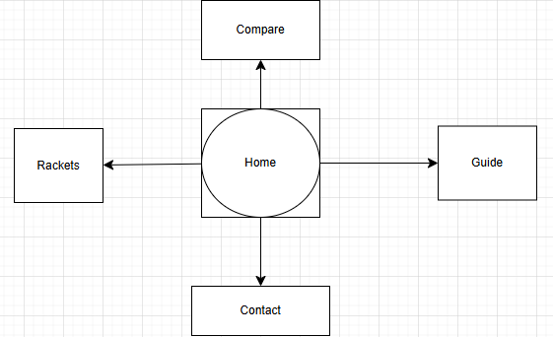

- Technical Brief
Technologies Used:
- HTML5
- CSS3
- BOOTSTRAP
- JAVA SCRIPT
Tools & resources
- Visual Studio Code
- GitHub
- GitHub pages

